SEC Form 4

FORM 4

Check this box if no longer subject to Section 16. Form 4 or Form 5 obligations may continue. See Instruction 1(b).

UNITED STATES SECURITIES AND EXCHANGE COMMISSION
Washington, D.C. 20549
 |  | OMB APPROVAL
STATEMENT OF CHANGES IN BENEFICIAL OWNERSHIP
 |  | OMB Number: | 3235-0287
 |  | Estimated average burden
Filed pursuant to Section 16(a) of the Securities Exchange Act of 1934 |  | hours per response: | 0.5
or Section 30(h) of the Investment Company Act of 1940
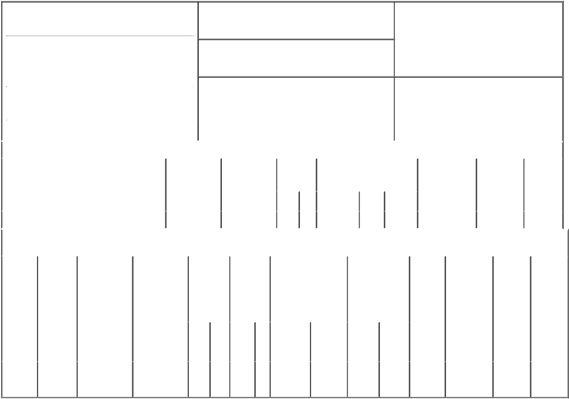

1. Name and Address of Reporting Person*
Gephart Brian

(Last) (First) (Middle)

C/O MAGNITE, INC.

6080 CENTER DRIVE, 4TH FLOOR

2. Issuer Name and Ticker or Trading Symbol

MAGNITE, INC. [ MGNI ]

3. Date of Earliest Transaction (Month/Day/Year)

07/01/2021

- Relationship of Reporting Person(s) to Issuer (Check all applicable)

 | Director | 10% Owner
X | Officer (give title | Other (specify
 | below) | below)

Chief Accounting Officer

 |  |  |  |  |  |  | 4. If Amendment, Date of Original Filed (Month/Day/Year) |  |  |  |  |  |  |  | 6. Individual or Joint/Group Filing (Check Applicable
 | (Street) |  |  |  |  |  |  |  |  |  |  |  |  |  | Line)
 |  |  |  |  |  |  |  |  |  |  |  |  |  |  |  | X Form filed by One Reporting Person
 |  | LOS ANGELES CA |  |  | 90045
 |  |  |  |  |  |  |  |  |  |  |  |  |  |  |  |  |  |  | Form filed by More than One Reporting
 |  |  |  |  |  |  |  |  |  |  |  |  |  |  |  |  |  |  | Person
 |  | (City) | (State) |  | (Zip)
 |  |  |  | Table I - Non-Derivative Securities Acquired, Disposed of, or Beneficially Owned
 | 1. Title of Security (Instr. 3) |  |  |  | 2. Transaction |  |  | 2A. Deemed |  | 3. |  | 4. Securities Acquired (A) or |  |  |  |  |  |  | 5. Amount of |  | 6. Ownership |  | 7. Nature
 |  |  |  |  | Date |  |  | Execution Date, |  |  | Transaction | Disposed Of (D) (Instr. 3, 4 and 5) |  |  |  |  |  |  | Securities |  | Form: Direct |  | of Indirect
 |  |  |  |  | (Month/Day/Year) |  |  | if any |  |  | Code (Instr. |  |  |  |  |  |  |  | Beneficially |  | (D) or Indirect |  | Beneficial
 |  |  |  |  |  |  |  | (Month/Day/Year) |  | 8) |  |  |  |  |  |  |  |  | Owned Following |  | (I) (Instr. 4) |  | Ownership
 |  |  |  |  |  |  |  |  |  |  |  |  |  |  |  |  |  |  | Reported |  |  |  | (Instr. 4)
 |  |  |  |  |  |  |  |  |  |  | Code V | Amount |  | (A) or | Price |  |  |  | Transaction(s)
 |  |  |  |  |  |  |  |  |  |  |  |  |  | (D) |  |  |  |  | (Instr. 3 and 4)
 | Common Stock |  |  |  | 07/01/2021 |  |  |  |  |  | A | 18,268⁽¹⁾ |  | A | $0.00⁽²⁾ |  |  | 18,268 |  |  |  | D
 |  |  |  |  | Table II - Derivative Securities Acquired, Disposed of, or Beneficially Owned
 |  |  |  |  | (e.g., puts, calls, warrants, options, convertible securities)
 | 1. Title of |  | 2. | 3. Transaction | 3A. Deemed | 4. |  | 5. Number |  | 6. Date Exercisable and |  |  | 7. Title and Amount |  |  |  | 8. Price of |  |  | 9. Number of |  | 10. | 11. Nature
 | Derivative |  | Conversion | Date | Execution Date, | Transaction of |  |  |  | Expiration Date |  |  | of Securities |  |  |  | Derivative |  |  | derivative |  | Ownership | of Indirect
 | Security |  | or Exercise | (Month/Day/Year) | if any | Code (Instr. |  | Derivative |  | (Month/Day/Year) |  |  | Underlying |  |  |  | Security |  |  | Securities |  | Form: | Beneficial
 | (Instr. 3) |  | Price of |  | (Month/Day/Year) | 8) |  | Securities |  |  |  |  | Derivative Security |  |  |  | (Instr. 5) |  |  | Beneficially |  | Direct (D) | Ownership
 |  |  | Derivative |  |  |  |  | Acquired |  |  |  |  | (Instr. 3 and 4) |  |  |  |  |  |  | Owned |  | or Indirect | (Instr. 4)
 |  |  | Security |  |  |  |  | (A) or |  |  |  |  |  |  |  |  |  |  |  | Following |  | (I) (Instr. 4)
 |  |  |  |  |  |  |  | Disposed |  |  |  |  |  |  |  |  |  |  |  | Reported
 |  |  |  |  |  |  |  | of (D) (Instr. |  |  |  |  |  |  |  |  |  |  |  | Transaction(s)
 |  |  |  |  |  |  |  | 3, 4 and 5) |  |  |  |  |  |  |  |  |  |  |  | (Instr. 4)
 |  |  |  |  |  |  |  |  |  |  |  |  |  |  | Amount
 |  |  |  |  |  |  |  |  |  |  |  |  |  |  | or
 |  |  |  |  |  |  |  |  |  |  |  |  |  |  | Number
 |  |  |  |  |  |  |  |  |  | Date |  | Expiration |  |  | of
 |  |  |  |  |  | Code V |  | (A) | (D) | Exercisable |  | Date | Title |  | Shares
 | Stock
 | Option |  | $34.68 | 07/01/2021 |  |  | A | 13,594 |  | (3) |  | 07/01/2031 | Common |  | 13,594 |  |  | $0.00⁽²⁾ |  | 13,594 |  | D
 | (Right to |  |  |  |  |  |  |  |  |  |  |  |  | Stock
Buy)

Explanation of Responses:

- Represents restricted stock units that vest as follows: 4,948 on August 15, 2022, 1,142 on each November 15, February 15, May 15 and August 15 thereafter until May 15, 2025 and 758 on August 15, 2025, subject to the Reporting Person's continued service to the Issuer through each vesting date. This equity grant may be subject to accelerated vesting in the event the Reporting Person's employment is terminated under certain circumstances.

- Equity grant under the Issuer's 2014 Equity Incentive Plan.

- 25% of the total number of shares underlying the option will vest on June 28, 2022 and the remaining shares vest 1/36 per month over the next 36 months thereafter, subject to the Reporting Person's continued service to the Issuer through each vesting date. This equity grant may be subject to accelerated vesting in the event the Reporting Person's employment is terminated under certain circumstances.
Remarks:

/s/ Aaron Saltz, attorney-in-fact 07/02/2021

** Signature of Reporting Person Date

Reminder: Report on a separate line for each class of securities beneficially owned directly or indirectly.

* If the form is filed by more than one reporting person, see Instruction 4 (b)(v).

- Intentional misstatements or omissions of facts constitute Federal Criminal Violations See 18 U.S.C. 1001 and 15 U.S.C. 78ff(a). Note: File three copies of this Form, one of which must be manually signed. If space is insufficient, see Instruction 6 for procedure.
Persons who respond to the collection of information contained in this form are not required to respond unless the form displays a currently valid OMB Number.

